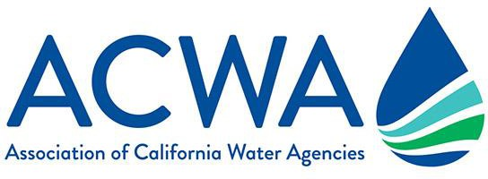

Agriculture-Related Talking Points on 2021 Drought Conditions

As we begin to enter warmer months in drought conditions, communicating with customers, stakeholders and media is essential to providing insight into California water managers’ ongoing preparedness for climate resiliency. This is also an opportunity to highlight the need for more statewide and local investments in water infrastructure and resiliency.
ACWA has prepared the following talking points to assist member agencies within California’s agricultural community as they engage with customers and stakeholders at the local level.

Agriculture is playing an important role in improving climate resiliency.
- [AGENCY NAME HERE] has a long history of working closely with farmers to help them adapt to dry conditions.
- California farmers are facing drought challenges by implementing sustainable practices that help slow climate change. Agricultural practices like reduced tillage, cover crops, and diversified crop rotations are methods for pulling carbon dioxide out of the atmosphere and storing this greenhouse gas in the ground.
- Farmers’ use of solar, wind and other clean energy sources help farms reduce their carbon footprint while preserving the ability to grow food.
- Water transfers between willing sellers and willing buyers help stretch California's water supplies in dry times and move water to places of critical need. Farmers are helping drive this innovative adaptation to the impacts on water supply from climate change.

With “boom or bust” water years becoming the new norm, we all knew we’d be back here again. Farmers are applying their experience from the past to the present.
- California farmers are constantly innovating, allowing them to conserve more water, use resources more efficiently, and continue supplying the healthy, safe, food supply we all count on.
- Continuous investments in water use efficiency technologies by California farmers have helped increase production, while at the same time demand for agricultural water has declined. For example, between 1999 and 2019 the water used to grow processing tomatoes has declined by 28% while production has increased by 38%.
- Scientists have warned that California weather will likely continue to boomerang between very wet and very dry years, making preparation for climate change critical for farmers and irrigation water managers.
- New technology, such as remote sensors and satellite imaging, allows farmers to monitor soil moisture and only use water where and when it’s needed. [INSERT AGENCY NAME] offers [INSERT INFORMATION ABOUT APPLICABLE REBATES, OR PROGRAMS].
- Increased use of recycled and reclaimed water allows [INSERT AGENCY NAME HERE] to use less fresh water. [INSERT ANY DETAILS ON FACILITIES AND/OR APPLICABLE FIGURES]. In fact, more than 75% of the growth in reclaimed water use nationwide comes from California.
- Farmers have invested heavily in more efficient irrigation systems, including expanded use of drip, micro-sprinkler and subsurface irrigation. In fact, California farmers have installed 69% of the country’s micro-irrigation. Where on-farm flood irrigation is used, it serves a multi-beneficial purpose by recharging groundwater basins.

The agriculture community continues pioneering multi-beneficial uses for water through projects that improve California ecosystems while making our water supply more reliable for everyone. This includes:
- Restoring natural ecosystem functions and fish and wildlife habitat, which is an important component of a healthy water supply. [INSERT ANY DETAILS ON A SPECIFIC PROJECT OR PROGRAM IF APPLICABLE].
- Utilizing functional flows and ecosystem water budgets to provide water to threatened species where and when they need it, while maintaining water supply for people, businesses and farms.
- Reactivating flood plains and flooding farm fields in winter to help manage flood control while also providing habitat for wildlife using the Pacific Flyway.

