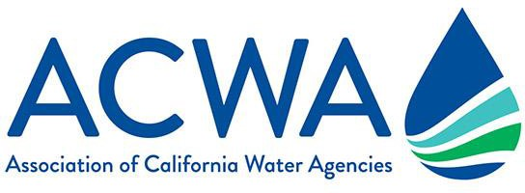

Talking Points on 2021 Drought Conditions

As we begin to enter warmer months in drought conditions, communicating with customers, stakeholders and media is essential to providing insight into California water managers’ ongoing preparedness for climate resiliency. This is also an opportunity to highlight the need for more statewide and local investments in water infrastructure and resiliency.

ACWA has prepared the following talking points to assist member agencies as they engage with customers and stakeholders at the local level.

Investments In Infrastructure Increase Water Supply Reliability
- Together with our customers, our agency has invested [INSERT DOLLAR FIGURE IF YOU HAVE IT] in developing and managing drought-resilient water supplies [CITE SPECIFIC PROJECTS SUCH AS DESALINATION, WATER REUSE, GROUNDWATER STORAGE, ETC.].
- Planning for periodic dry years and drought is part of responsible water management in California. Water agencies throughout the state have developed plans to address climate change.
- In addition to local investment, action must be taken at the state and federal levels to improve our aging water infrastructure to realize a more reliable, resilient water supply for our people and food supply as the extremes of climate change grow more severe.
- Uncertainties, such as new regulations, natural disasters and unpredictable climate are constant reminders of how important it is to invest in increased statewide storage and diversified water supplies.
- It often takes 10 years or longer to realize the benefits of investments into more resilient and reliable water supplies.

California Drought Statistics/Supplies
- The state’s current snowpack is approximately 69% of normal for this date in the Northern Sierra, 66% for Central Sierra and 44% for Southern Sierra. Weather conditions through March will play a large part in determining how California will be impacted. (Statistics are as of March 29. Check DWR’s website for updated figures.)
- California’s current reservoir conditions vary throughout the state: Lake Shasta, the state’s largest reservoir located in Northern California, was at 52% of capacity (65% of historical average); San Luis Reservoir in Central California was at 55% of capacity (61% of historical average); Castaic Lake was at 76% of capacity (85% of historical average). (Statistics are as of March 29. Check DWR’s website for updated figures.)
- [INSERT AGENCY NAME HERE] will assess conditions on an ongoing basis to ensure we have sufficient water supplies for the community and will keep customers informed as the situation changes.
Long-term Water Efficiency Remains a Way of Life
- During the 2012-2016 drought, [INSERT AGENCY NAME] customers reduced water use by [XX%] and currently use less water than 2013 levels thanks to increased awareness about water efficiency and use of [INSERT AGENCY NAME] conservation rebate and incentive programs. This long-term change will help our community undergo what may be the second dry winter in a row.
- California has experienced many periods of drought and weather extremes due to climate change, which will continue to occur more frequently. Continuing to make water efficiency a California way of life will help the state stay prepared for all climactic extremes.
- As we move into the hotter, summer months, we will continue to thank our customers for their ongoing water-use efficiency achievements and remind them to keep using water wisely as a way of life in California.
- [INSERT AGENCY NAME] values efficient water use and offers customers numerous rebate and incentive programs to be more water efficient. [INSERT DETAILS ABOUT REBATES, RESOURCES, WEBINARS AND PROGRAMS].
- Californians can practice water efficiency year-round and make a difference by finding and fixing leaks, taking shorter showers and installing California-friendly landscapes.

